PROJECT REPORT

UNLOCKING INSIGHTS INTO THE GLOBAL AIR TRANSPORTATION NETWORK WITH TABLEAU

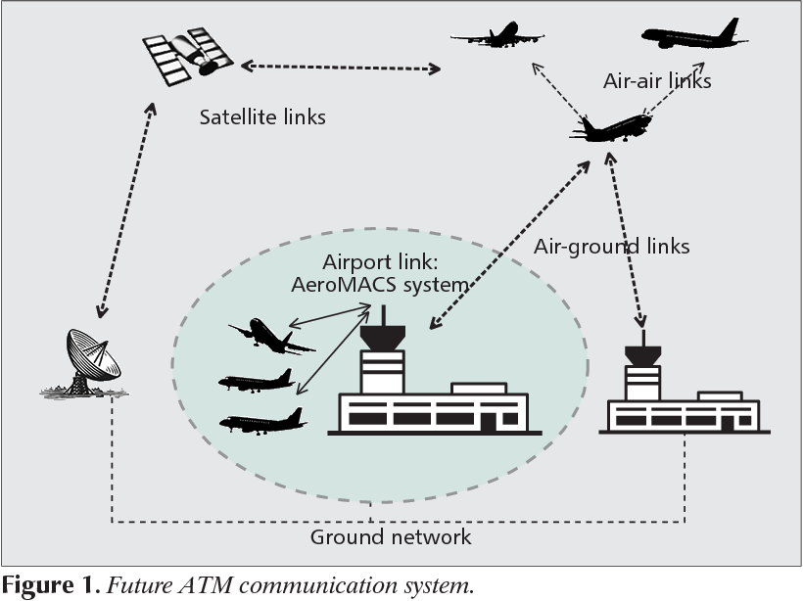

Team Members

k.Gopiga

S.Vaishnavi

O.Madhumitha

R.Logeshwari

INTRODUCTION

OVERVIEW:

This Global Air Transportation Network dataset is a comprehensive collection of information on airports, airlines and their routes. It contains information such as names, cities, countries, codes (IATA and ICAO) Longitudes, latitudes and altitudes of airports across the world with detailed time zone and daylight saving time data.

PURPOSE:

Air Transport allows people from different countries to cross international boundaries and travel other countries for personal, nosiness, medical, and tourism purposes.

ROBLEM DEFINITION AND DESIGN THINKING

EMPATHY MAP:

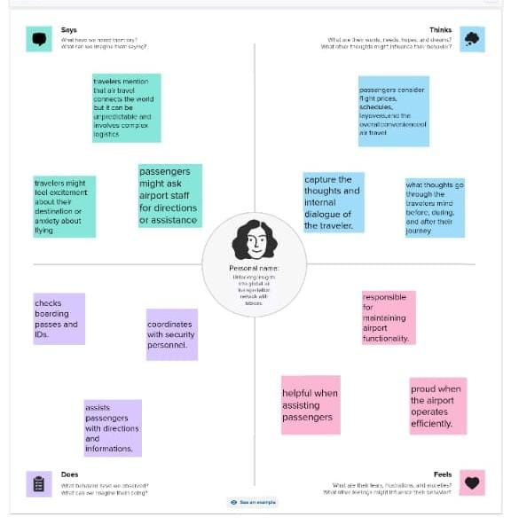

BRIANSTORM MAP:

